**SRATEGY REPORT**

**of**

**STRATEGIC MANAGEMENT**

**on**

**AMAZON Inc.**

*Submitted in partial fulfillment of requirements for the award of degree*

***Master of Business Administration***

# Submitted by: -

BAIBHABA NATH (234024004)

Under the guidance of:

# Dr. Sumant Kumar Bishwas



**SCHOOL OF BUSINESS**

**Indian Institute of Technology, GUWAHATI**

|  |  |
| --- | --- |
| **Members** | **%Contribution** |
| **1. Baibhaba Nath (234024004)** | **100%** |
|  |  |
|  |  |

# ACKNOWLEDGEMENT

We express our sincere thanks to Dr. Sumant Kumar Bishwas, Assistant Professor, School of Business for he gave us the opportunity to do a Strategy Analysis project report on Amazon. He also gave us valuable suggestions and help in preparing this project report. We shall be always grateful and thankful to him.

Table of Contents 1.Introduction 4

1. Vision 4
2. Mission 4
3. Amazon Core values 5
4. Business Model 6
5. Strategic Group mapping 7
6. SWOT Analysis of Amazon 8
7. VRIN Analysis 10
8. Weighted Competitive Strength 11
9. Diversification Path for Amazon in India 12
10. The Winning Strategy of Amazon 12
11. PESTEL Analysis 14
12. Porter’s Five Forces Analysis 16
13. Retrenchment Strategies used by Amazon 17
14. Balance Scorecard 18

# Introduction

Amazon Inc (a US based company), stepped into the Indian market in 2013 with the launch of its online marketplace, Amazon.in. Since then, the company has rapidly expanded its operations and established a strong presence in India.

Today, Amazon India offers a wide range of products across major broad categories from electronics, fashion, home and kitchen, grocery, to much more. The company has also launched several initiatives in India, including Amazon Prime, Amazon Pay, and Amazon Web Services (AWS).

Amazon has invested heavily in building its logistics and delivery infrastructure, along with a talented pool of human resources in India. It includes building fulfillment centers and last-mile delivery capabilities. The company has also established partnerships with local retailers and logistics providers to further expand its reach in the country.

To cater to local consumer preferences, Amazon has introduced several initiatives such as "*Amazon Easy*" which provides assisted shopping services to customers in remote and rural areas. Amazon has also launched a regional languages interface for its platform to cater to non-English speaking customers – adapting to the needs of Indian customers.

Amazon's presence in India has grown rapidly and significantly over the years and is continuing, and the company is considered one of the top e-commerce players in the country. It’s focus on building a localized and customer-centric business model has helped it to establish a strong foothold in the Indian market despite of strong environment forces.

# Vision

Our vision is to be earth's most customer-centric company; to build a place where people can come to find and discover anything they might want to buy online.

# Mission

"Amazon is guided by four principles: customer obsession rather than competitor focus, passion for invention, commitment to operational excellence, and long-term thinking. Customer reviews, 1-Click shopping, personalized recommendations, Prime, Fulfillment by Amazon, AWS, Kindle

Direct Publishing, Kindle, Fire tablets, Fire TV, Amazon Echo, and Alexa are some of the products and services pioneered by Amazon."

# Amazon Core values

* + Customer Obsession: Leaders start with the customer and work backwards. They work vigorously to earn and keep customer trust. Although leaders pay attention to competitors, they obsess over customers.
  + Ownership: Leaders are owners. They think long term and don't sacrifice long-term value for short-term results. They act on behalf of the entire company, beyond just their own team. They never say "that's not my job."
  + Invent and Simplify: Leaders expect and require innovation and invention from their teams and always find ways to simplify. They are externally aware, look for new ideas from everywhere, and are not limited by "not invented here." As we do new things, we accept that we may be misunderstood for long periods of time.
  + Learn and Be Curious: Leaders are never done learning and always seek to improve themselves. They are curious about new possibilities and act to explore them.
  + Hire and Develop the Best: Leaders raise the performance bar with every hire and promotion. They recognize exceptional talent, and willingly move them throughout the organization. Leaders develop leaders and take seriously their role in coaching others.
  + Insist on the Highest Standards: Leaders have relentlessly high standards—many people may think these standards are unreasonably high. Leaders are continually raising the bar and drive their teams to deliver high-quality products, services, and processes.
  + Think Big: Thinking small is a self-fulfilling prophecy. Leaders create and communicate a bold direction that inspires results. They think differently and look around corners for ways to serve customers.
  + Bias for Action: Speed matters in business. Many decisions and actions are reversible and do not need extensive study. We value calculated risk-taking.
  + Earn Trust: Leaders listen attentively, speak candidly, and treat others respectfully. They are vocally self-critical, even when doing so is uncomfortable or embarrassing. Leaders do not believe their or their team's body odor smells of perfume. They benchmark themselves and their teams against the best.
  + Deliver Results: Leaders focus on the key inputs for their business and deliver them with the right quality and in a timely fashion. Despite setbacks, they rise to the occasion and never settle.

# Business Model of Amazon Products/Services

It's an e-commerce platform that sells a wide range of products, including books, electronics, clothing, home goods, and more. It also offers various services, such as Amazon Prime, Amazon Web Services (AWS), Amazon Advertising, and Amazon Music.

# Revenue Streams

They generate revenue through the sale of products and services, as well as through third-party seller fees, subscription fees for Amazon Prime, and fees for AWS usage.

# Customer Segments

Their customer base includes individuals, businesses, and government organizations. It serves customers in various countries, with a focus on India, North America and Europe.

# Value Proposition

Their value proposition includes a wide selection of products and services, competitive pricing, fast and convenient delivery, and a user-friendly online shopping experience.

# Cost Structure

Amazon incurs costs related to product procurement, order fulfillment, marketing and advertising, technology development and maintenance, and general overhead.

# Strategic Group mapping

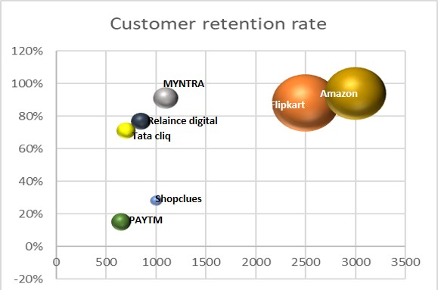

X axis – average order value in INR Y axis – customer retention rate

Radius of the circle represents the Market share

|  |  |  |  |
| --- | --- | --- | --- |
|  | **Average order value**  **(INR)** | **Customer retention rate** | **Market Share** |
| Flipkart | 2500 | 88% | 31.90% |
| Amazon | 3000 | 94% | 31.2% |
| Shopclues | 1000 | 28% | 1.03% |
| Paytm Mall | 650 | 15% | 3.3% |
| Myntra | 1100 | 91% | 4.70% |
| Tata cliq | 700 | 71% | 3% |
| Reliance digital | 850 | 77% | 3% |

Ref:https:/[/www.spglobal.com/m](http://www.spglobal.com/marketintelligence/en/news-insights/latest-news-)a[rketintelligence/en/news-insights/latest-news-](http://www.spglobal.com/marketintelligence/en/news-insights/latest-news-) headlines/flipkart-is-no-1-in-india-but-faces-formidable-foe-in-amazon-say-experts-54083920

The above strategic group mapping portrays the group positions of the cluster of ecommerce companies in India on the measures of customer retention rate (y axis) and average order value in INR (x axis). As we can see from the radius that both amazon and flipkart are in the same cluster and are close in their customer retention rates. Amazon leads flipkart in the retention aspect as it has a very efficient customer centric approach. Market share of flipkart is very slightly more than that of amazon. This is largely because flipkart has presence in T2 and T3 cities more than that of Amazon.

Although the retention rate of Myntra is comparable to that of the flipkart and amazon, but the market share and average order values are very less. This is because Myntra is focused on the apparels and fashion clothing and accessories, whereas amazon and flipkart are diversified in a lot more products and services. PayTM mall is positioned very low in both the aspects – the frauds associated with the Paytm malls are also one of the main reasons for this.

TATA cliq and reliance digital form the next cluster – mainly T1 an T2 cities – with limited presence. They are relatively limited to select cities in their physical stores and online presence. They are each other’s competitors.

# SWOT Analysis of Amazon

This analysis is performed for the presence of Amazon company within India. Certain examples which are relevant from the international territories are also incorporated in this analysis.

# Strengths

1. Robust logistics and distribution systems, IT systems, data centres (Amazon Web Services)
2. Network of Large number of third-party sellers
3. Cost effective – no physical retail stores
4. Innovative with products & technology – alexa, solimo, drone delivery systems
5. Successful brand image – globally
6. High Indian market capitalization & global presence
7. Extensive product mix – 75 million products being sold and delivered
8. Strong financial position and ability to invest in growth and expansion
9. Convenient for customers + convenient for suppliers to put items on sale

# Weakness

1. Imitable business model example: flipkart, meesho
2. Thin profit margins for the company, including services like Amazon prime, also in grocery segment
3. Inhumane work conditions for the workers (for US locations, as per the recent reports), thus a negative image being formed
4. Dependence on distributors
5. Product failures like – Kindle (unsustainable)
6. Prime delivery services are not uniform throughout Indian location, but the cost fo each user is same.

Example: In Guwahati, extremely limited product levels on Prime next day delivery, also average delivery time is 1 week, which is inconvenient when compared to physical stores

# Opportunities

1. Expanding physical stores in India
2. More acquisitions of e-commerce companies, for better penetration in the Indian market (Esp T2 cities
3. Supply chain strengthening – ex. Next day prime delivery in Guwahati
4. Better backward integration to increase margins & develop capability for physical stores
5. More marketing for new products like Prime music to generate more revenue from the rivals like Spotify
6. Autonomous driving vehicles in India like US
7. Drone technology implementation collaboration with the institutes and government (Amazon already has good drone technology system in US, & can extend to India)

# Threats

1. Aggressive competition ex Flipkart, meesho, Netflix
2. Fake products and sellers
3. Customer complaints tarnishing brand image
4. Government regulations – favored to local companies like Reliance (Jiomart)
5. Hyperlocal deliveries capturing better market share in T1 cities
6. Online frauds and phishing attacks
7. Companies building their own delivery force (example croma)

# VRIN Analysis

Valuable – Rare – Inimitable – Non-substitutable

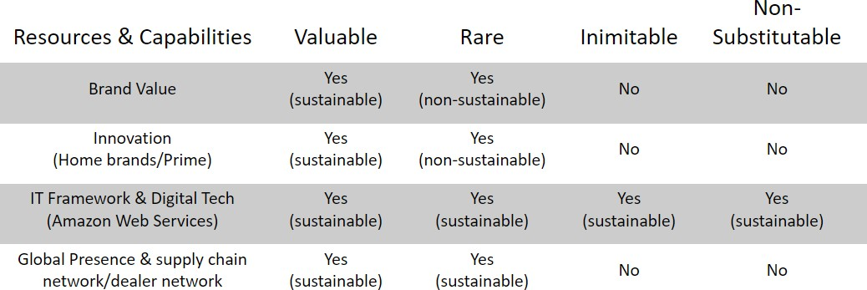

# Brand Value:

The brand value is valuable as it has become a household name in India. And since, is has captured a significant market share in India, it is not easy for any other company to set up their such strong brand value so fast to give a competition throughout all the territories in India.

# Innovation:

Amazon has a very strong innovation driven system that continuously works for the betterment of product and services. It is valuable for the company as it provides a strong backbone to flourish their business but it is not rare as companies like Walmart have also started to invest heavily on their patents technology and are aggressively taking on innovation driven businesses. Moreover, in the IT platform business, the changes and updates are rapidly being neutralized.

IT framework:

All the factors in this resource are sustainable. Companies throughout the globe have strong dependence on Amazon Web Services to conduct their businesses. This resource is difficult to copy easily, although Walmart is still a close competitor as it has already developed strong data center to generate its own data of businesses and customers.

# Global presence & supply chain:

With the rapid digitization and increasing connectivity of the Transporation, from the company’s perspective, these resources are sustainable but many more companies are budding up with the local government’s support very rapidly so it may not be inimitable and non-substitutable for Amazon.

# Weighted Competitive Strength

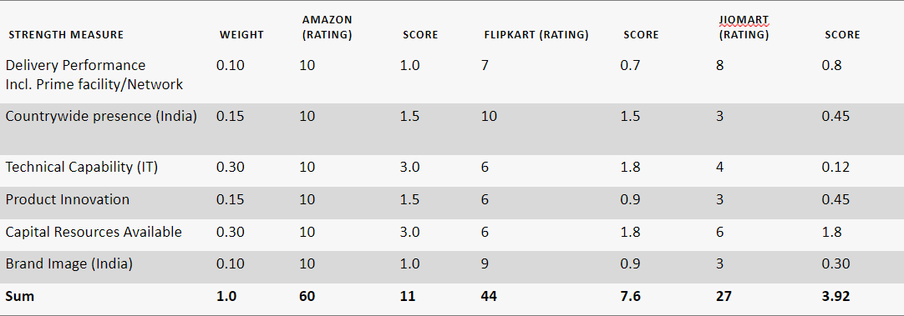

Close competitor of amazon in Indian market is Flipkart. But Flipkart lacks behind in many aspects such as product innovation, satisfying customer complaints. Also, there have been many cases of frauds during the sale season by Flipkart. Thus, Amazon has developed greater trust amongst people in India markets especially T1 and T2 cities. Flipkart dominates much in the T3 cities of India. Next competitor is JioMart. It does not have much score currently. But since with the government’s favorable policies, and good capabilities of the financial resources, it has possibility to develop into a greater force competitor of Amazon.

So, amazon has to develop greater strategic intent in order to maintain and expand its position in the Indian markets.

# Diversification Path for Amazon in India – Unrelated Business

We have selected a path of unrelated business expansion in India based on its strengths and resources and capabilities and the high consumer demand and lucrative market of this unrelated segment for Amazon.

Autonomous driving vehicles segment:

* + The autonomous driving and electric vehicle segment:
  + Possess generic resources & capabilities – acquires zoox of US
  + Industry attractiveness and growth potential – yes, also, with increasing govt incentives
  + Corporate targets for profitability and ROI: high consumer demand for electric vehicles & vision for autonomous vehicles in T1 cities
  + Contribution to parent company's PPP: clean fuel vehicles, more convenient means of transport, first mover advantage with existing brand name, populous country – high demand

Drone technology segment:

* + Amazon has established drone delivery system in the US.
  + It can leverage its strength in India, collaborate with the institutions, agri sector and provide efficient solutions to the problems that can be resolved through drone technology.
  + This along with the government’s initiatives will be very fruitful as the market has a great potential ongoing.
  + Also, a major player like amazon’s breakthrough into this market will make a significant impact and will be advantageous due to its good brand value.

# The Winning Strategy of Amazon Strategic Fit Test

The strategic fit test checks how well a company's strategy aligns with its external environment, internal resources & capabilities. Here's how Amazon's strategy in India fits the strategic fit test:

External Environment:

* + Industry environment - The Indian e-commerce industry is growing rapidly, with increasing technology penetration and a large consumer market. Amazon offers a wide range of products and services and improves customer experience and fits well with this industry requirement.
  + Competitors - there is an intense competition from local e-commerce players such as Flipkart and Snapdeal, who have an edge in understanding of the local market and consumer preferences. Amazon's strategy of stepping into the local structures like hyper local deliveries and partnerships and a connect with both suppliers and customers fits well in this case.

Internal Resources and Capabilities:

* + Customer-centric culture –It has a culture of customer obsession fits well with its strategy which offers a personalized and seamless shopping experience and various services like Prime to customers in India hassle free.
  + Technology – with high end technological capabilities, powered by AI, cloud, data centers, enable it to provide personalized recommendations and streamline operations in India.
  + Supply chain and logistics - Strong supply chain and logistics network, great human resource which specialize in this field in India is a good alignment for its strategy which offers quick and trustworthy delivery to customers.

Thus, it has a well aligned strategy that passes the strategic fit test.

# Performance Test:

Financial Indicators:

Strong revenue growth, esp in covid - revenue for the fiscal year 2021 increased by 63 percent to 15,000 crore.

Profitability: by 2021, the company’s losses narrowed 5,849 crores for FY’21.

Market Share: increased from 32% to 35% from the year 2019 to 2021 (approximate figures) Non-Financial Performance:

Customer Satisfaction: one of the consistently performing top e-commerce company in India as it is one of the only two major players in the Indian e-commerce industry.

Product Range – a wide variety of product range, including the company’s self-developed brands like Solimo and even the refurbished market.

Innovation – products and services like Prime Video, Amazon pay, Amazon web services. Thus, a strong performance in Indian markets and acing the performance test.

# Competitive advantage test:

Competitive advantage based on:

* + Brand Recognition
  + Technological capabilities
  + Strong supply chain and logistics
  + Diversified product offering + broad segment of customers
  + Dealer network and partnerships
  + Lower delivery costs (low-cost provider emphasis) Thus, a good performance in this test.

Overall, amazon stands strong in its winning strategy.

# PESTEL Analysis

By using the PESTEL framework, Amazon can identify the external factors that may affect its business and develop strategies to mitigate risks and capitalize on opportunities.

# Political Factors:

In 2021, Amazon faced allegations of anticompetitive business practices in India. The Competition Commission of India (CCI) launched an investigation into Amazon for alleged anti- competitive practices, including exclusive deals with certain sellers and preferential treatment to select sellers.

# Economic Factors:

In the Finance Bill 2021-2022, the Indian government introduced a 2% digital service tax on foreign e-commerce companies, including Amazon. the tax applies to online sales of goods and services made by non-resident companies to customers in India.

# Sociocultural factor:

the increasing online buying habits and consumerism in developing countries, as well as the growing wealth disparity between developed and developing nations, present both opportunities and challenges for Amazon and other e-commerce companies. As consumer habits and economic conditions continue to evolve, these trends will shape the future of the e-commerce industry.

# Technological Factors:

* 1. Amazon's virtual assistant, has been used to recommend products and services to customers, leading to a significant increase in sales. According to Amazon, product recommendations by Alexa have led to a 35% increase in sales.
  2. AWS, Amazon's cloud computing platform, has also been a significant driver of growth for the company. AWS provides a range of cloud-based services and solutions to businesses and organizations, including storage, computing, and analytics.
  3. The growth of mobile usage in India has led to a shift towards mobile app shopping and a focus on creating a seamless shopping experience for mobile users.

# Environmental factors:

1. Decarbonizing the supply chain: Amazon has set a goal to reach net-zero carbon emissions by 2040 and has pledged to achieve this by decarbonizing its supply chain.
2. Sustainable packaging: Amazon has implemented several measures to reduce waste and increase the use of sustainable packaging materials.
3. Developing more sustainable transportation infrastructure: Amazon has also invested in developing more sustainable transportation infrastructure, including electric delivery vehicles, hybrid electric trucks, and even drones for last-mile delivery

# Legal factors:

1. Government regulation: Government regulations are constantly evolving, and unfavorable changes could harm Amazon's business. For example, Amazon is currently facing increased scrutiny from regulators and lawmakers around the world over issues such as antitrust, data privacy, and labor practices.
2. Layoffs: Amazon has faced criticism for its treatment of workers and has been accused of violating labor laws in some countries.
3. Fines for privacy violations: Amazon has also faced fines and legal action over privacy violations. In 2021, the company was fined $887 million by the European Union for violating data protection laws

# Porter’s Five Forces Analysis Threat of New Entrant (LOW)

* + Customer base (H)

Amazon has a vast customer base, with millions of active customers worldwide. So, it is difficult for new entrants to enter and compete with Amazon.

* + Strong brand recognition(H)

Amazon is one of the world's most recognizable and valuable brands, with strong brand recognition across the globe. This is due to the company's relentless focus on customer satisfaction, continuous innovation, and dedication to providing a wide selection of products at competitive prices.

* + Switching Costs(L)

Switching Cost is low because there are several options are available for customers like Flipkart, Paytm mall etc.

* + Supply chain(H)

Amazon has one of the most extensive and complex supply chains in the world. The company's supply chain involves multiple steps, including procurement, warehousing, transportation, and delivery. So, it is difficult for new entrants to achieve that kind of supply chain.

# Bargaining power of buyers (HIGH)

* + Other platforms offer similar products(L)
  + Indian buyers are more price Sensitive(L)

Amazon's customers have High bargaining power due to the abundance of online retailers and the ease of comparing prices. Additionally, Amazon's focus on providing a positive customer

experience creates a competitive advantage that gives customers more leverage when negotiating with Amazon.

# Bargaining power of Suppliers (LOW TO MODERATE)

* + Availability of substitutes(H)
  + Size of the supplier(H)
  + Switching costs(L)

Amazon's suppliers have limited bargaining power due to Amazon's size and purchasing power. Amazon can negotiate favorable terms and prices with its suppliers, which puts pressure on the suppliers to lower their prices. Additionally, Amazon has been known to develop its own products and services, which reduces its dependence on external suppliers.

# Threat of substitute (HIGH)

* + Other E commerce i.e flipkart (L)
  + local e-commerce player (M)
  + Offline Shops (M)

Amazon faces a high threat of substitutes as there are many other online retailers that offer similar products and services. Additionally, brick-and-mortar retailers can also be considered substitutes for Amazon, particularly for customers who prefer to shop in-person.

# Competitive rivalry (HIGH)

* + Competition from established players like Flipkart, Shopclues and Paytm Mall
  + Expanding their services
  + Continuously innovating

Amazon faces intense competition from other online retailers such as Walmart, Target, and Alibaba, as well as from brick-and-mortar retailers who have expanded their online presence. Additionally, the low barriers to entry in the online retail market make it easy for new competitors to enter the market

# Retrenchment Strategies used by Amazon Turnaround Strategy

Amazon has implemented a turnaround strategy to overcome its financial struggles in the early 2000s. The company shifted its focus to e-commerce, expanded its product range, and invested heavily in technology and infrastructure.

# Diversification

Amazon has expanded into multiple areas beyond their initial focus on selling books online. They now offer a wide range of products and services, including streaming video, music, and cloud computing.

* + Horizontal diversification: Amazon has expanded its business horizontally by offering a wide range of products and services, such as books, electronics, clothing, food, and web services. This has allowed the company to target a larger customer base and increase its market share.
  + Vertical integration: Amazon has also diversified its business vertically by integrating its supply chain and logistics operations. The company owns and operates its own fulfillment centers, delivery trucks, and even planes, allowing it to control the entire process from the time a customer places an order to the time it is delivered.

# Acquisition Strategy

Amazon has also pursued an acquisition strategy, acquiring companies such as Whole Foods Market and Ring, a smart home security company. Amazon has also acquired a number of startups in order to gain access to new technologies and talent. For example, Amazon acquired Ring, a smart doorbell company, in 2018 to expand its smart home offerings.

# Innovation Strategy

Amazon's innovation strategy has led to the introduction of new products such as the Amazon Go stores and the Amazon Fire TV Stick. They also collaborates with external partners and suppliers to create innovative solutions that benefit its customers.

# Balance Scorecard

The Balanced Scorecard is a strategic management tool that helps organizations align their business activities with their vision and strategy. It consists of four perspectives: Financial, Customer, Internal Business Processes, and Learning and Growth.

Financial Perspective: This perspective measures Amazon's financial performance and how well it is achieving its financial objectives. Amazon tracks its revenue growth, profit margins, return on investment, and cash flow to ensure that it is financially healthy.

* + Customer Perspective: This perspective measures how well Amazon is meeting the needs and expectations of its customers. Amazon tracks its customer satisfaction, market share, customer retention, and brand loyalty to ensure that its customers are happy and loyal to the brand.
  + Internal Business Processes Perspective: This perspective measures how well Amazon's internal business processes are operating and how efficiently it is executing its operations. Amazon tracks its order fulfillment cycle time, inventory turnover, operational efficiency, and product development cycle time to ensure that it is delivering its products and services efficiently and effectively.
  + Learning and Growth Perspective: This perspective measures how well Amazon is investing in its employees and infrastructure to support its strategic goals. Amazon tracks its employee satisfaction and engagement, employee training and development, innovation and continuous improvement, and information technology infrastructure to ensure that it is constantly learning and growing.
  + By using the Balanced Scorecard, Amazon can monitor its performance across these four perspectives and ensure that it is effectively executing its strategy. The company can identify areas of improvement and take appropriate actions to achieve its goals and objectives.

|  |  |  |  |  |
| --- | --- | --- | --- | --- |
| **Perspecti ve** | Objective | Measure | Target | Initiatives |
| Financial | Increase revenue and profitability | Revenue growth rate, Net income, EBITDA  margin | Revenue growth rate of 20%, Net income | - Expand product offerings and increase marketing and advertising spend to drive revenue growth - Optimize supply chain to reduce  costs and improve EBITDA margin |

|  |  |  |  |  |
| --- | --- | --- | --- | --- |
|  |  |  | growth of 15% |  |
| Customer | Provide exceptional customer experience | Customer satisfaction  score, Net  Promoter Score  (NPS), Customer retention | Customer satisfaction score of 90%,  NPS of 70 | - Enhance website and mobile app design and functionality to improve user experience - Invest in customer service training to improve customer satisfaction and retention |
| Internal Processes | Streamline operations and improve efficiency | Order fulfillment time, Inventory turnover,  Return rate | Order fulfillment time of 2 days, Inventory turnover of 10, Return  rate of 5% | - Implement automation and robotics in warehouses to improve order fulfillment time - Use data analytics to optimize inventory levels and improve inventory turnover - Streamline returns process and offer free returns to reduce return rate |
| Learning and Growth | Invest in innovation and employee  development | Employee training hours, Employee engagement score, Number of patents filed | 20 hours of employee training per year, Employee engagement score of 80%, File 100  patents per  year | - Provide ongoing training and development opportunities to employees - Encourage innovation and creativity through company culture and incentives - Increase R&D investment to drive patent filings and technological innovation |

By tracking and measuring these objectives and targets, Amazon can monitor its performance across different perspectives of the business and take appropriate actions to improve and achieve its strategic goals.